New Release
28 September 2021

SNOOP DOGG DROPS RED WINE WITH NEW 19 CRIMES COLLAB

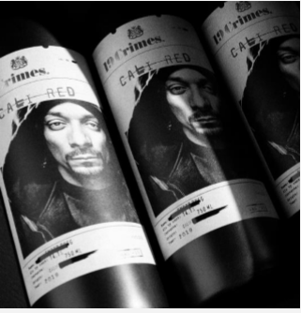
Step aside Graham Norton, John Legend, Brad Pitt, Angelina Jolie, Post Malone and Jay Z, there’s a new dog in the wine house. Known more for music partnerships with Katy Perry, Dr. Dre and Bruno Mars, Californian-raised rapper Snoop Dogg has partnered with 19 Crimes and released Snoop Cali Red, a full and dense petite syrah, zinfandel and merlot blend with fruit-forward notes of raspberry, strawberry, and red cherry.

Grown and blended in California, bottled in Australia, and marketed in New Zealand by Asahi Beverages NZ (through its partnership with Treasury Wines), the 19 Crimes Snoop Cali Red range is now ready for drinking across several vintages for a limited time.

A smash overseas, the 19 Crimes Snoop Cali Red juggernaut has taken the wine world by storm and Li Camilleri, Senior Brand Manager Wine at Asahi Beverages NZ expects the same response from Kiwi wine consumers – and old school hip-hop fans.
“Snoop Cali Red won the number one wine innovation of 2020 when first launched in the USA and has won numerous awards since. It exceeded initial 12-month sales forecast in the first two months of launch in the USA and we’re really excited to be bringing it to New Zealand.”
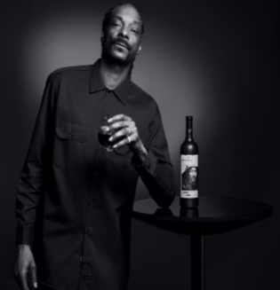
Remembered for songs like 'Gin & Juice,’ Snoop Dogg is excited to have swapped rhythms for vines and to be serving up Snoop Cali Red for the very first time.
“I’m excited to bring ‘Snoop Cali Red’ to my Kiwi peeps and share the experience with my fans. 19 Crimes is one of the most successful brands in the market, so I’m more than eager to bring this collaboration to the world!”
“I believed in myself when the world tried to train a dog not to. Got to thank myself for that. Already did and I’m gonna do it again. Glasses up let’s make a toast to success and nothing less, yes sir. They call me the dogfather, King of the West Coast and I was born to defy society.” Snoop Dogg.
This passion comes to life through augmented reality labels on each of his new wine bottles accessed through an app offering trademark thrown-down lines like, “I believed in myself when the world tried to train a dog not to. Got to thank myself for that. Already did and I’m gonna do it again. Glasses up let’s make a toast to success and nothing less, yes sir. They call me the dogfather, King of the West Coast and I was born to defy society.”
Second chances are a fundamental value of 19 Crimes and Snoop Dogg describes the wine range as the taste of redemption – a bit like his own personal journey.
Camilleri says it’s been 15 years since Snoop Dogg toured New Zealand and she’s super excited to have him back in bottle form with this limited release series available through supermarkets, select liquor stores and restaurants for RRP $19.99 per bottle.
Seeking more on this wine?
Contact Jo Jalfon
Asahi Beverages NZ
027 201 2645
jo.jalfon@asahi.co.nz

