**Media Release**

**24 March 2022**

**Trip to Raro on the cards for Drury resident after winning $200k with Long White**

Drury resident Tiana Tamariki was literally jumping for joy last week when she found out she had won $200,000 simply tagging friends on Instagram.

Tiana was one of over 180,000 Kiwis who entered a Long White Vodka competition asking entrants to tag three friends @longwhite.nz. No product purchase was required with organiser Long White Vodka simply seeking to help Kiwi’s ‘live their free’ after lockdowns and border closures on and off for two years.

Tiana was ‘shocked and grateful’ to win $200,000 after entering the competition several times over summer. Upon being told she’d been chosen at random as the winner Tiana said she “could not believe it” but that she was would be planning a trip to Rarotonga with her husband to see her grandfather and would share some of her winnings with her family.

To further mark her celebration, Long White Vodka sent Tiana two boxes of her favourite flavours namely Passionfruit, and Mango and Mandarin.

Long White Vodka was developed by Asahi Beverages in 2007 and is now the biggest selling RTD brand in New Zealand.

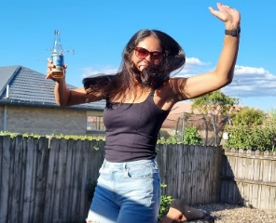

**Caption:** Tiana Tamariki.

**ENDS**

**For more information please contact:**

Jo Jalfon

Manager, Corporate Communications

Asahi Beverages NZ

Tel: 027 201 2645

Email: [jo.jalfon@asahi.co.nz](mailto:jo.jalfon@asahi.co.nz)